


Viewing a Filing
for the
Interstate Insurance Product Regulation Commission
(Insurance Compact)
Instructions for Compact States

Before you begin: To view or update an Insurance Compact filing, a state user must have certain roles assigned to their ID. If you are unable to view Insurance Compact filings, contact the SERFF Help Desk at serffhelp@naic.org.

These instructions assume working knowledge of the SERFF application from a state perspective. Users who have not previously worked in SERFF should download and review the SERFF user manual, available at www.serff.com.

Notification for Insurance Compact Filings

- When an Insurance Compact filing is submitted, the Compact States included on that filing (“Compact States”) will receive a message in their SERFF Message Center. Users with the correct Compact roles will receive this message, if they have opted into receiving such messages. The message will indicate that the submission was to the Insurance Compact.

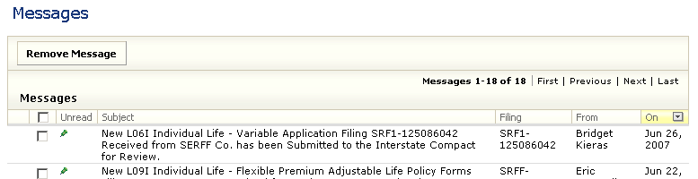

- Authorized users (those state reviewers with the correct Compact roles) can access the filing by following the link in the message or through the Search feature. Insurance Compact filings will not appear in the Open filings or Intake view for a Compact State, and they cannot be added to the user’s Workfolder.

Searching for Insurance Compact Filings

- Insurance Compact filings will return in the search results for an authorized user of a Compact State included on the filing. In addition to the regular search criteria, the option to choose Compact only (or to exclude Compact) can be set under the Interstate Compact setting. This setting will only appear for authorized users.

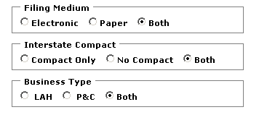

- Insurance Compact filings will also be included in exports using the Export Tool if they meet the criteria entered.

Viewing Insurance Compact Filings

In most ways, an Insurance Compact filing will be similar in appearance to a regular state filing. The differences include:

- The filing will be identified as “Interstate Compact” in the upper right hand corner of the Filing at a Glance section.

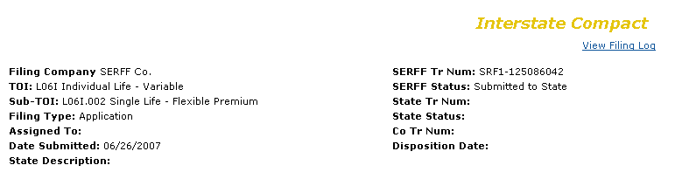

- The companies displayed on the Companies and Contact tab are only those companies listed on the filing and associated with the Compact State viewing the filing.
- The information displayed on the Supporting Documentation tab and the State Specific Fields tab reflects the requirements of the IIPRC, not of the individual states. For the ease of matching the filing with state-required disclosures and/or illustrations, the company may file those documents under the Supporting Documentation for the States to review. The Insurance Compact does not review the disclosures and/or illustrations submitted under Supporting Documentation for the States benefit.
- The Filing Fees tab will reflect the fees paid to the Compact State viewing the filing. If the Compact State has no fees, no information will display here. If the Compact State does have fees, both the Overall Fee section and the EFT section should display. If you happen to notice that the fees are incorrect, please contact the Insurance Compact office and address the issue with the office.
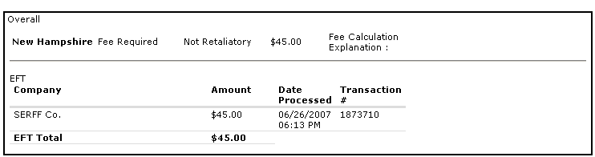

- Compact States can view Correspondence on an IIPRC filing, but cannot create such.

Insurance Compact Filings in the EFT Reports

Insurance Compact filings are included in both the summary and detail reports for EFT. In the summary report, they are simply included in the total for each company. In the detail report, Insurance Compact filings will be denoted by the “IC” entry in the column to the left of SERFF Tracking Number, as shown below.

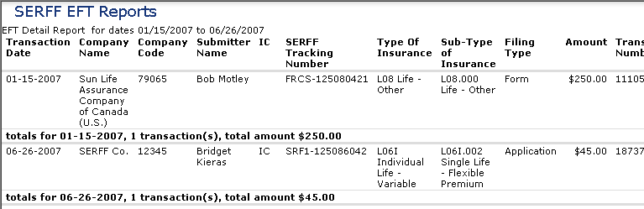

Updating Fields on Insurance Compact filings

Compact States may only update specified fields on an Insurance Compact filing. These fields are:
  - State Tracking Number
  - State Status
  - State Description

To make these changes, the Compact State user should click the Update button, enter the appropriate values, and click Save.

It is important to note that the information in these fields will only be available to the state that entered it. It cannot be viewed by the Insurance Compact reviewers, by other Compact States, or by industry. These notations are internal to the state only.

PDF Pipeline

Compact States may PDF Pipeline Insurance Compact filings, but will only be able to Pipeline the portions of the filing that have been marked for Public Access.

